INTRODUCTION

This document outlines Development Review Application requirements in relation to the long-term environmental sustainability and climate resilience of buildings within Somerville. Development proposals that require Site Plan Approval by the Somerville Zoning Ordinance must include a completed Sustainable & Resilient Buildings Questionnaire (Questionnaire) with the required Development Review Application. A Development Review Application is considered incomplete unless a completed questionnaire is submitted with the application. It is strongly recommended that the development team meets with staff from the Office of Sustainability and Environment prior to submitting the Development Review Application.

The purpose of this Questionnaire is to minimize the adverse environmental impacts in the design, construction, and occupancy of buildings in Somerville and to ensure that the impacts of future climate conditions are carefully evaluated.

Please review the following documents before completing the Questionnaire:

- Somerville Climate Change Vulnerability Assessment
- Carbon Neutrality Pathway Assessment
- Somerville Climate Forward

PROCEDURE:

A completed Sustainable & Resilient Buildings Questionnaire must be submitted with a Development Review Application for all development proposals that require Site Plan Approval. New construction or alterations to existing structures of 25,000 square feet or more must also submit an updated Questionnaire prior to the issuance of the first Building Permit and prior to the issuance of the first Certificate of Occupancy to identify any design changes made subsequent to Site Plan Approval or additional information determined as the development process unfolds.

BACKGROUND: CARBON NEUTRALITY

Understanding the global imperative to reduce greenhouse gas emissions in order to prevent extreme changes to the climate, Mayor Joseph A. Curtatone set a goal for Somerville to become carbon neutral by the year 2050. Carbon neutrality is defined as the net-zero release of carbon dioxide and other greenhouse gases (GHG) within Somerville’s municipal boundary. Reducing greenhouse gas emissions is critical to avoiding the worst impacts of climate change and to protecting the health, safety, and welfare of current and future generations. In 2017, the Somerville Board of Aldermen passed a resolution reaffirming the city’s carbon neutrality goal. And In 2018, Somerville released its first community-wide climate action plan, Somerville Climate Forward.

To achieve carbon neutrality by 2050 and to minimize adverse environmental impacts, Somerville will need to drastically reduce greenhouse gas emissions from electricity, buildings, transportation, and waste disposal. To meet these goals, all buildings within the city will need to pursue net zero emissions. New development should be designed to maximize envelope performance and energy efficiency, produce or procure renewable energy, and phase out fossil fuel use through electrification of building systems. The City of Somerville recognizes that as technology advances, incorporating design elements to mitigate carbon emissions and increase resilience may become more feasible. Applicants are asked to devise strategies that permit building systems to adapt and evolve over time to further reduce GHG emissions and to avoid path dependency that perpetuates reliance on fossil fuels.

BACKGROUND: CLIMATE CHANGE VULNERABILITY

Despite efforts to minimize greenhouse gas emissions, climate change is already impacting Somerville and changes to the climate will continue to intensify. The City of Somerville’s Climate Change Vulnerability Assessment analyses vulnerabilities associated with Somerville’s key climate stressors: increased precipitation, sea level rise and storm surge, and higher temperatures. The analysis recommends that new development consider these climate impacts and take appropriate measures to address the projected climatic conditions described in the assessment.

Several areas of Somerville are already prone to flooding from intense precipitation. With climate change, precipitation events will become more intense—meaning that a greater volume of rain will fall in a shorter period of time. Somerville is projected to experience more than a 30% increase in rainfall during a 100-year 24-hour event. This increase in precipitation will increase the risk of flooding in areas where the drainage system does not have sufficient capacity.

In addition to flooding from precipitation, sea level rise and storm surge are already potential concerns for areas of East Somerville and by 2035-2040 the Amelia Earhart Dam could be regularly flanked by storms, resulting in flooding for areas of Assembly Square, Ten Hills, and Winter Hill.

As the climate continues to change, average seasonal temperatures are also expected to increase and the number of days above 90 degrees Fahrenheit (historically about 10 a year) could rise to 40 days by 2030, a third of the summer, and 90 days by 2070, nearly the entire summer. In 2018 there were 23 days over 90 degrees.
As temperatures increase, Somerville will become more susceptible to the urban heat island effect which causes hotter temperatures due to paved surfaces and waste heat generated by energy use when compared to less developed areas. Increasing average temperatures can have wide-ranging impacts on human life, the built environment, and natural ecosystems. Rising temperatures and more intense heat waves present significant public health concerns and can contribute toward kidney, lung, and heart problems. Vulnerable populations are particularly susceptible to heat-induced illness and mortality. There will also be increasing demand for indoor cooling.

The following maps and figures provide an overview of projected climate exposure. Please review the Climate Change Vulnerability Assessment for more detailed analysis on Somerville’s exposure, vulnerability, and risk to climate change. For higher resolution maps and GIS files, please contact Hannah Payne, Sustainability Coordinator, at hpayne@somervillema.gov.

2070 Coastal Flood Probability

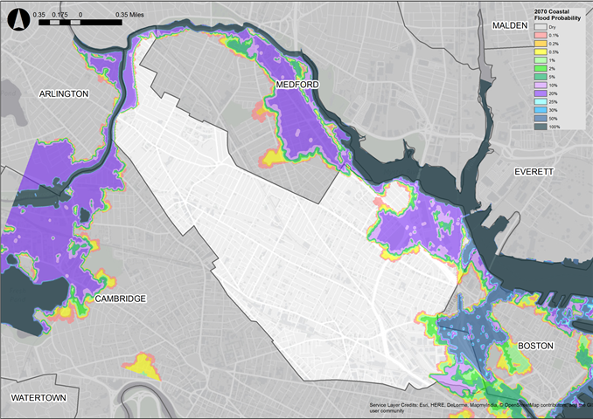

This map shows the annual chance of flooding from coastal storm events and sea level rise in 2070. A 100% chance of flooding means that there is a nearly certain chance that the area will flood at least once in a given year, while a 50% chance means that there is an equal chance that it may or may not flood in a given year. A 1% chance of flooding corresponds with a 100-year event. A 0.1% chance corresponds with a 1000-year event. This map does not account for drainage (Somerville Climate Change Vulnerability Assessment, 2017)

2070 Coastal Flood Depth from 2070 100-year Storm Event

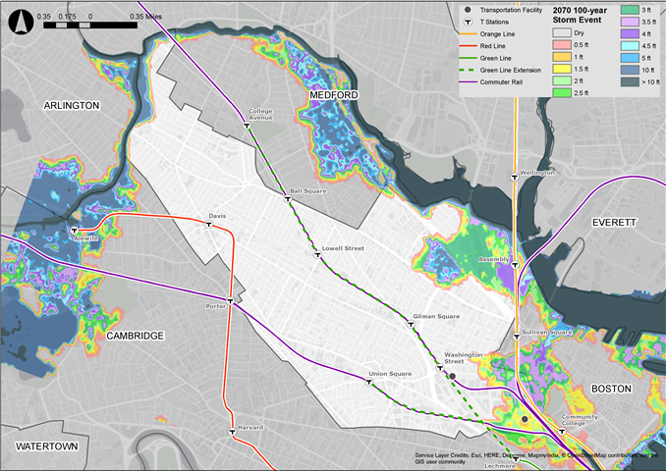
This map shows the projected flood depths of a 100-year coastal storm event in 2070 along with public transportation infrastructure assets. This map does not account for drainage (Somerville Climate Change Vulnerability Assessment, 2017)

Precipitation Projections
Precipitation-based flooding is projected to increase in Somerville and is currently more of an immediate and widespread threat than sea level rise and storm surge. The intensification of both the frequency and intensity of rainfall events is likely to cause increased risk of flooding during rain events.

Storm Type | Present-day  Rainfall | 2030  Rainfall | 2070  Rainfall
10-year (10% annual chance), 24-hour | 4.9 in | 5.6 in | 6.4 in
100-year (1% annual chance), 24-hour | 8.9 in | 10.2 in | 11.7 in

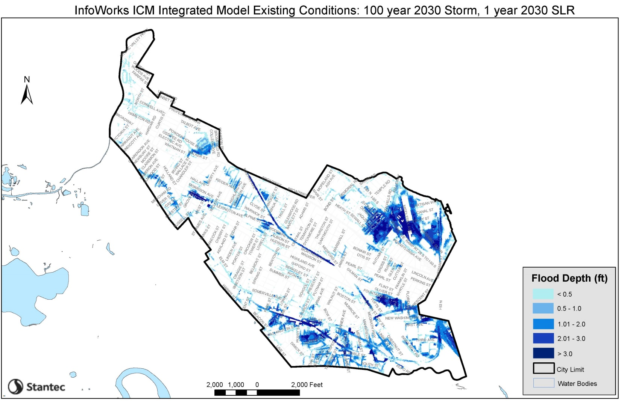This map shows the impact of both precipitation-based flooding and sea level rise and storm surge. This map shows the modeled flood depths of a 100-year, 24-hour Design Storm with 1-year storm surge and sea level rise projections in 2030. Unlike the maps above, this includes modeling of the drainage system, which takes into account how water will be conveyed out of the city. The model is based on how the system is designed to function, so actual areas of flooding and depth of flooding could vary (Stantec, 2019).

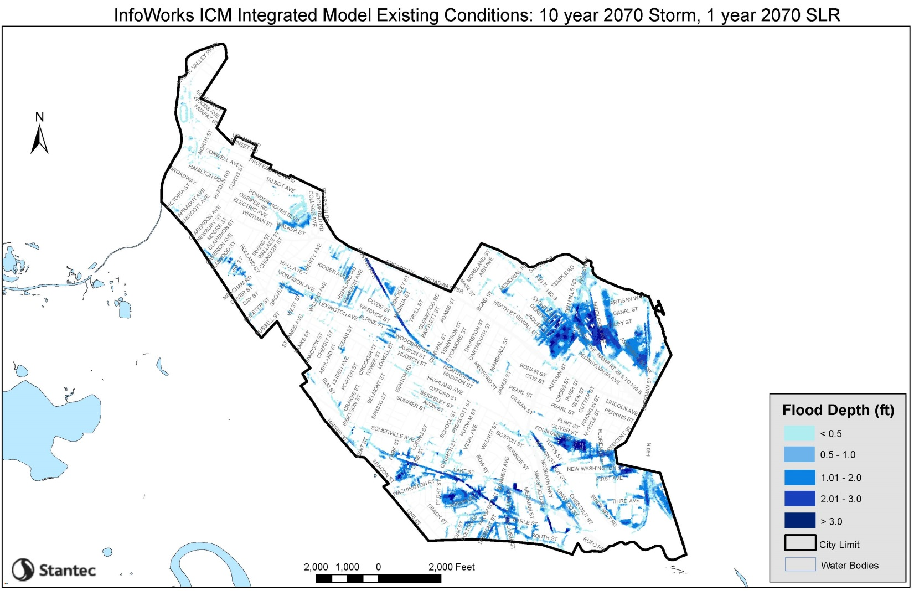
This map shows the impact of both precipitation-based flooding and sea level rise and storm surge. This map shows the modeled flood depths of the 10-year, 24-hour Design Storm with 1-year storm surge and sea level rise projections in 2070. This map includes modeling of the drainage system, which takes into account how water will be conveyed out of the city. The model is based on how the system is designed to function, so actual areas of flooding and depth of flooding could vary (Stantec, 2019).

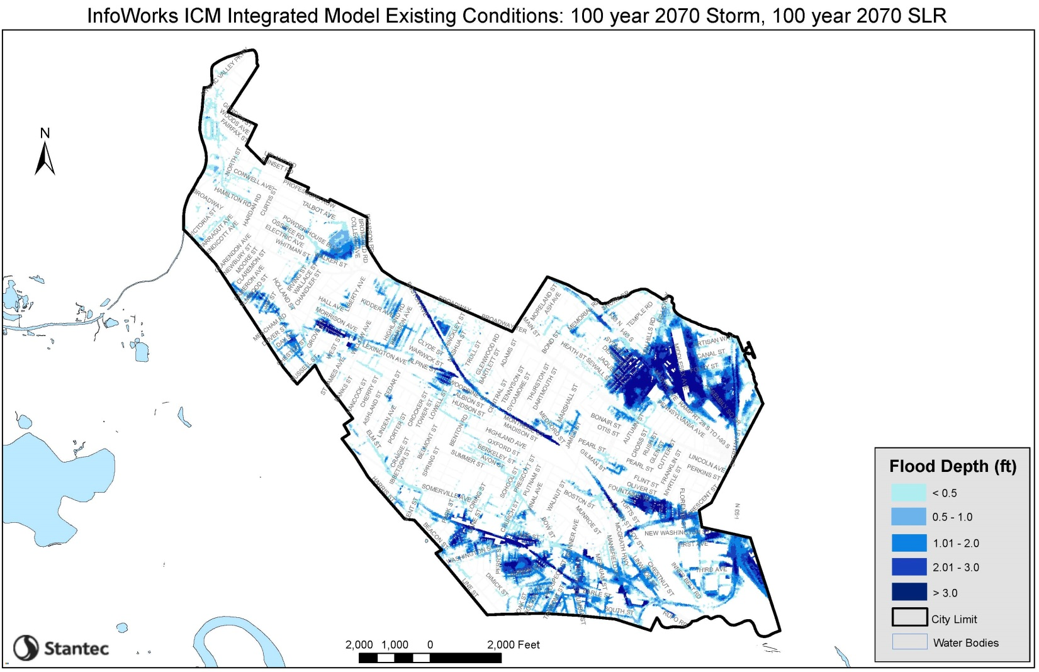
This map shows the impact of both precipitation-based flooding and sea level rise and storm surge. This map shows the modeled flood depths of 2070 100-year, 24-hour Design Storm with 100-year storm surge and sea level rise projections in 2070. This map includes modeling of the drainage system, which takes into account how water will be conveyed out of the city. The model is based on how the system is designed to function, so actual areas of flooding and depth of flooding could vary (Stantec, 2019).
Temperature Projections

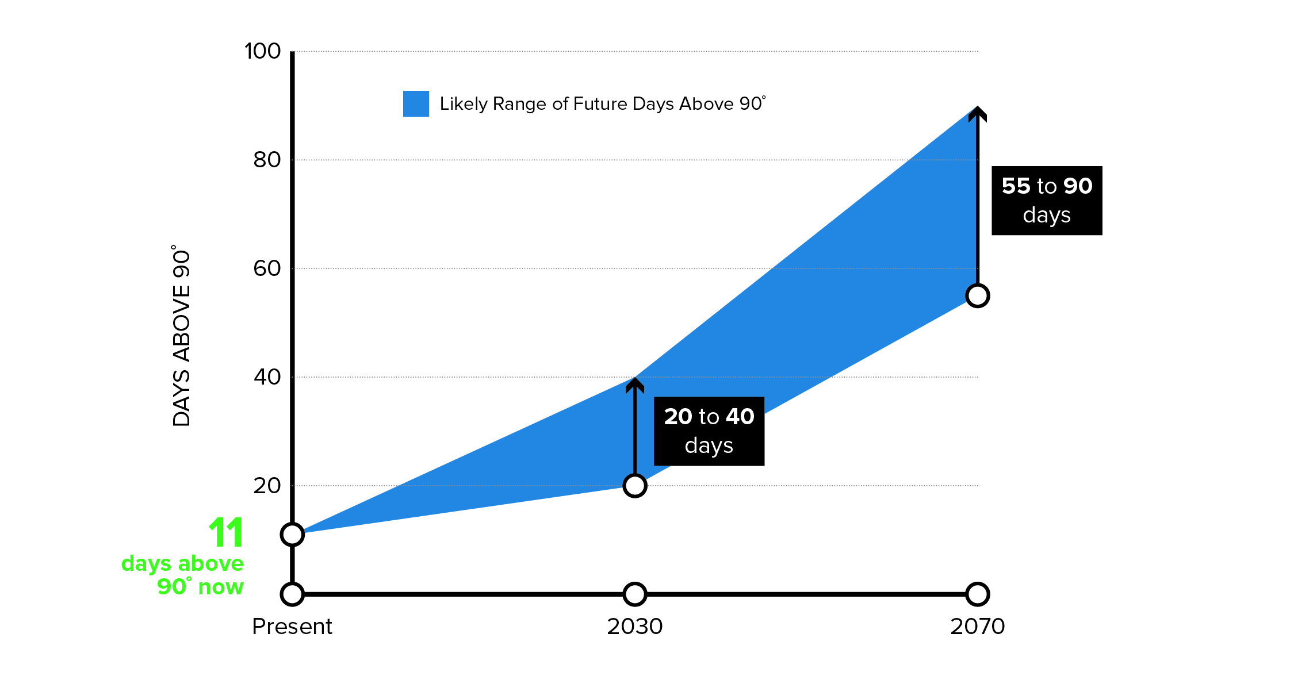
(Somerville Climate Change Vulnerability Assessment 2017)

Temperature | 1971-2000  (average) | 2030  (low) Avg. (high) |  | 2070  (low) Avg. (high)
Annual | 50.0º F | 53.3º F | 53.5º F | 55.8º F | 58.7º F
Summer | 70.6º F | 74.5º F | 74.8º F | 77.4º F | 80.6º F
Winter | 29.8º F | 32.2º F | 33.0º F | 34.6º F | 38.0º F

RESOURCES:
For information on net-zero and resilient building and site design, please review the following resources:
- Passive House Principles
- Architecture 2030 Palette (Net-zero design tools)
- Building Resilience in Boston
- Enhancing Resilience in Boston
- A Better City’s Resiliency Toolkit
- Ready to Respond: Strategies for Multifamily Building Resilience

For additional information visit www.somervillema.gov/sustainaville
SUSTAINABLE & RESILIENT BUILDINGS QUESTIONNAIRE

Section 1: Proposal Information

Proposal Name
Address

Developer
Business Address
Designated Contact
Telephone Number
Contact’s Email Address
Date Submitted
Filing Type (Development review application, Building Permit, or CoA)
Is this a revised Questionnaire?
Is MEPA Approval Required? | Yes/No; Why?
Section 2: Building & Site Details

2.1 Building Information
Building Uses
Gross Floor Area
Expected Life of Building
Expected Life of Building Systems: HVAC, electrical, boilers, plumbing, telecom, lighting, energy management.
Type of Heating System(s)
Type of Cooling System(s)
2.2. Green Building
Green Building Professional(s): Name(s) and contact information
Professional Credentials: Green Building Program Certification(s)
Building LEED Rating | Certifiable/Silver/Gold/Platinum
Building LEED Point Score

Will you pursue LEED certification through the USGBC?

Are any other green building certifications being pursued? (Passive House, Enterprise Green Communities, etc.). Please describe.
2.3. Electric Vehicle Parking | The number of electric vehicles (EVs) in Somerville is expected to increase significantly over the next decade with more electric vehicles coming to market than ever before. Conservative estimates based on historical trends alone suggest 20% of personal vehicles in Somerville will be electric by 2040. Installing capacity for EV supply equipment (EVSE) has been shown to be more feasible and cost effective during construction than when retrofitting parking areas to support the installation of EVSE in the future. Providing EVSE can increase the property value, become a future revenue source, and provide an amenity that more tenants and commuters will be looking for. It is recommended that parking facilities be designed to allow for the most flexibility to adapt to future needs of electric vehicles and changing mobility needs. The City of Somerville recommends 25% of spaces have installed charging access and up to 100% of spaces be “EV Ready” (everything but the station installed). Eversource currently has a program to pay the associated infrastructure costs of EV charging, including infrastructure needed to be “EV ready.” Please consult with Eversource to determine if any installation costs could be covered through their Make Ready Program.
Total # of Parking Spaces | #
EVSE Plugs (number and voltage/ level of plugs) | #
EV Ready Spaces (everything but station is installed) | #
Please share any other information on your EV strategy. Have you spoken with Eversource? Are you talking with EVSE providers? Have you considered EVSE needs in conjunction with your parking and mobility management plans?

2.4 Key Building Efficiency Metrics
The following should be provided for each building type (office, retail, multifamily, hotel, restaurant, etc.).

Vertical Envelope Performance

 | ASHRAE Reference Building |  |  | Proposed Building
Vertical Envelope | Percent of Vertical Area | R value  (see note 1) | U value  (see note 2) | Percent of Vertical Area | R value  (see note 1) | U value  (note 2)
Framed, insulated Wall | % | R+Rc.i. | U-value | % | R+Rc.i | U-value
Opaque glass, curtain wall, shadowbox, spandrel | NA – ASHRAE reference building has no spandrel |  |  | % | R+Rc.i | R+Rc.i.
Vision glass | % | R-value | U-value  (note 3) | % | R-value | U-value  (note 3)
 | 100% |  | Aggregate U (note 4) | 100% |  | Aggregate U (note 4)
 |  |  | Aggregate R |  |  | Aggregate R

Notes:
- Show in format of R+R c.i. where first R is amount of discontinuous insulation and second R is amount of continuous insulation.

- U values shall be based on indicated R+R c.i. and shall conform to Appendix A of ASHRAE 90.1 2013.

- U value includes frame, per NRFC standard methods.

- Aggregate U is calculated as: (U₁%₁ + U₂%₂ + U₃%₃) where U is the respective thermal transmittance values and %₁ is the percent area of framed insulated wall; %₂ is the percent area of opaque glass, curtain, or shadowbox; and %₃ is the percent area of vision glass. Only areas adjacent to conditioned space are counted, areas adjacent to unconditioned spaces (e.g. parking garages, mechanical penthouses) are not counted. Aggregate R is the inverse of aggregate U. For percent areas for ASHRAE reference building, see Table G3.1.1-1 in ASHRAE 90.1 2013.

Other Performance Metrics

 | ASHRAE Reference Building | Proposed Building
Air Infiltration (ACH 50)
Aggregate Vertical Envelope R
Roof R
Lowest level conditioned floor above unconditioned space (if any) R
Cooling End Use (kBtu/sf-yr)
Heating End Use (kBtu/sf-yr)
Peak Heating (kBtu/hr-sf)
Peak Cooling (kBtu/hr-sf)
Site EUI (kBtu/hr-sf)

Section 3. Planning for Net Zero Emissions and Energy Resilience

3.1. How is the building currently designed to reduce energy usage? Please describe the key design features of the building including:
A) Building envelope performance (including roof, foundation, walls, and window assemblies)
B) How has the design team integrated energy performance into the building and site design and engineering (orientation, massing, mechanical systems, envelope, etc.)?
C) Efficiency of heating and cooling systems. Will these systems be electric? Provide reasoning for selection of heating and cooling systems.

3.2 Will the building be a net zero carbon building? A net zero carbon building is a highly energy efficient building that does not burn fossil fuels and either produces or procures enough carbon-free electricity to meet the building’s total energy demand. If the building will not be a net zero carbon building, provide a technical description of how the building’s systems will be transitioned over time to achieve net zero carbon emissions, including how and when systems can be transitioned in the future to carbon-free alternatives (provide timeline including 2030, 2040, and 2050 targets). Description must include whether any remaining emissions will be offset with on-site or off-site renewables and at what quantity. Changes could include, but are not limited to, addition of on-site renewable energy generation, energy storage, additional energy efficiency measures, building electrification, or other measures that would further reduce greenhouse gas emissions.

3.3 Describe any and all incentives, rebates, grants provided by utilities, government organizations, and other organizations being pursued to maximize building efficiency and to reduce emissions. Description must include any incentives that were considered but are not being pursued, including reasoning for each decision.
3.4 Evaluate feasibility of on-site renewable generation. Please describe your analysis and findings. Analysis should consider incentives available. Will any renewable energy generation be incorporated into the project? If so, please describe (system type and capacity). If no, could it be added in the future? And will any off-site renewable energy be purchased?
3.5. Are any on-site energy storage systems planned? Please describe.
3.6 Does the electric utility’s infrastructure have enough capacity to support the addition of your building’s energy load? Please provide confirmation from utility.

3.7 Will the building’s roof include any sustainability features? These may include, but are not limited to, high albedo roof materials, solar panels, or vegetation. Please describe what features could be added in the future (i.e. roof will be designed to support solar or green roof installation of X size).

Section 4: Climate Change Risk and Vulnerability

4.1 Climate Vulnerability  Exposure  (check all that apply) | - Sea Level Rise & Storm Surge  - Precipitation Induced Flooding  - Heat  - Other(s):
4.2 How is your site vulnerable to projected climate change impacts?

The next two sections ask specific questions about how the project is designed to manage climate-related risks from heat, coastal and inland flooding.

Section 5: Managing Heat Risks

5.1 Describe all building features that will keep building occupants safe and comfortable during extreme heat, including mechanical systems and non-mechanical design elements to cool building (orientation, envelope, operable windows, etc.).

5.2 How has increased demand for indoor cooling been factored into the building design and energy management strategy?

5.3 List any indoor spaces without cooling and their uses.

5.4 What design features will be implemented on site to minimize the site’s contribution to the urban heat island effect? Please describe any and all design elements. Strategies could include, but are not be limited to, the following:
- High albedo pavement or roof materials
- Passive cooling or increased ventilation capacity
- Green roofs or walls
- Heat resistant trees and plants
- Additional landscaped areas

Section 6: Managing Flood Risks

6.1 Is the site susceptible to flooding from sea level rise and storm surge and/or rain events now or during the building's expected lifetime? Please refer to the Somerville Climate Change Vulnerability Assessment and the updated stormwater flooding maps provided in the Background section of this Questionnaire. Additional maps and data are available by request (email hpayne@somervillema.gov)

If you answered YES to the previous question, please complete the remainder of Section 6. Otherwise, you have completed the Questionnaire. Thank you.

6.2 Flooding Design Considerations

Proposed Site Elevation - Low | (ft) | Proposed Site Elevation - High | (ft)
Lowest elevation of life-safety systems | (ft) | Proposed First Floor Elevation | (ft)
Nearest flood elevation for the 2070 10-year storm |  | Nearest flood elevation for the 2070 100-year storm
6.3 What are the first floor uses of the building? Are there any below ground stories of the building? If so, what uses are located below ground?
6.4 Are there any flood-sensitive assets, utilities, mechanical equipment, or life-safety systems located in areas of the building that are at risk of flooding? What measures will protect building systems during a flood or severe storm? These might include, but may not be limited to, the following:
- Elevation of utilities and mechanical systems
- Water tight utility conduits
- Waste water back flow prevention
- Storm water back flow prevention
- Systems located above the ground floor
- Securing objects at risk of becoming dislodged
6.5. Residential and commercial buildings should be designed to maintain regular operations during a 10-year storm in 2070. Describe how the site and building have been designed to maintain regular operations--meaning all systems will remain operational and all occupied spaces are protected from flooding-- during the 2070 10-year storm. Please refer to both the 2070 coastal flood probability map and the 2070 10-year storm and 1-year sea level rise scenario (pages 3 and 6). Resilience measures might include, but may not be limited to, the following:
- Elevation of the site
- Structural elevation of the building
- Non-structural elevation of the ground floor
- Energy storage and backup generation
- Wet flood-proofing (allowing water to flow through building envelope)
- Dry flood-proofing (preventing water from entering building)
6.6 Residential buildings should be designed to allow occupants to shelter in place during a catastrophic storm (100-year event) today and in the future, this means all life-safety systems should be above the 2070 100-year flood elevation. How will your site and building be impacted by the 2070 100-year, 24-hour storm and how will your site and building be designed to protect against those impacts? Please evaluate impact based on both the 2070 coastal flood depth model for the 100-year storm and the 2070 100-year, 100-year sea level rise model (pages 4 and 7). Summarize anticipated pre- and post-event policies, strategies, and actions necessary to facilitate post-flood recovery.
6.7 Will hazardous or toxic material be stored on site? Where will it be stored? How will you protect hazardous or toxic material from flooding?
6.8 Will the site be accessible by a typical vehicle during a 10-year event (up to 6 inches of water) and by emergency vehicles (up to 12 inches of water) during a 100-year event?

http://evchargingpros.com/wp-content/uploads/2017/04/City-of-SF-PEV-Infrastructure-Cost-Effectiveness-Report-2016.pdf; https://www.richmond.ca/__shared/assets/Residential_EV_Charging_Local_Government_Guide51732.pdf

